Product brief

WaterScope is a rapid, simple, digital, bacterial testing kit for drinking water allowing anyone to conduct a test in any location

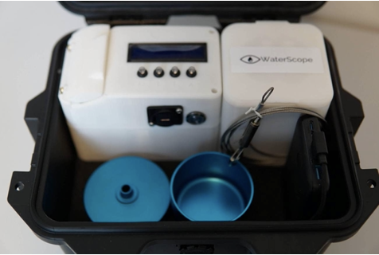
Key features and benefits

Easy-to-use metal cartridge

14 sample capacity

Follows ISO 9308-1

Relative risk level after 8 hours

Fully quantitative after 18 hours

Automatic colony counting

Embedded IoT with worldwide coverage

Android App + web dashboard

5.8 kg with all consumables

Complies with IATA carriage rules

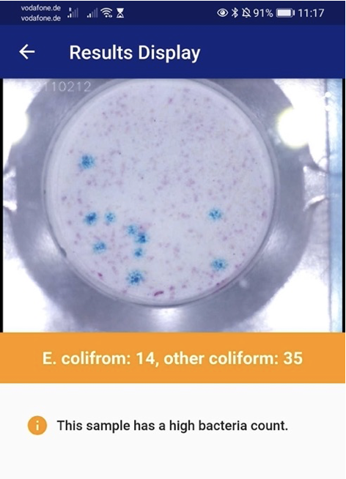
The WaterScope system is low-cost, light, easily transportable (<6 kg), and can be easily operated making it ideal for use in low and middle-income countries. The system features a patented cartridge technology, which allows for testing to be completed without knowledge in aseptic methods. The system follows the ISO 9308-1 standard and uses a conventional method of using a membrane to filter the water to isolate the bacteria, and adding nutrient media to allow bacteria to grow.

Automated sample analysis

By using high resolution microscopy and image recognition software, the system can identify bacterial colonies. Automated counting and identification removes dependent skill sets of personnel making the test faster and more effective than current systems which use personnel to identify bacterial colonies by eye.

Data dissemination and connectivity

The data from the system is uploaded automatically to our dashboard for mapping and intervention, ensuring that the integrity of the water test results is maintained throughout all stages of the process. The dashboard allows institutions/governments/NGOs to monitor tests in particular areas, assign responsible people to take action and manage their assets.

Portable water test kit comparison
There are two main methods for microbiological testing of water in the field: membrane filtration kits (such as Del Agua, Trace2O, Wagtech) and most probable number methods, (Compartment Bag Test from Aquagenx). The main differences between the two kits are in the sample preparation effort with CBT being significantly easier to use but not quantitative, and the cost/accuracy with MF based tests being cheaper and fully quantitative, but complex. WaterScope is trying to address the shortcomings of these two tests by providing an easy-to-use water test that also provides the accuracy of the MF tests. In addition, the WaterScope system provides an online dashboard where the results can be seen and is able to distinguish between E.coli and other coliform bacteria. Figure 1 shows a comparison between the three kits in terms of the time it takes to prepare a sample.
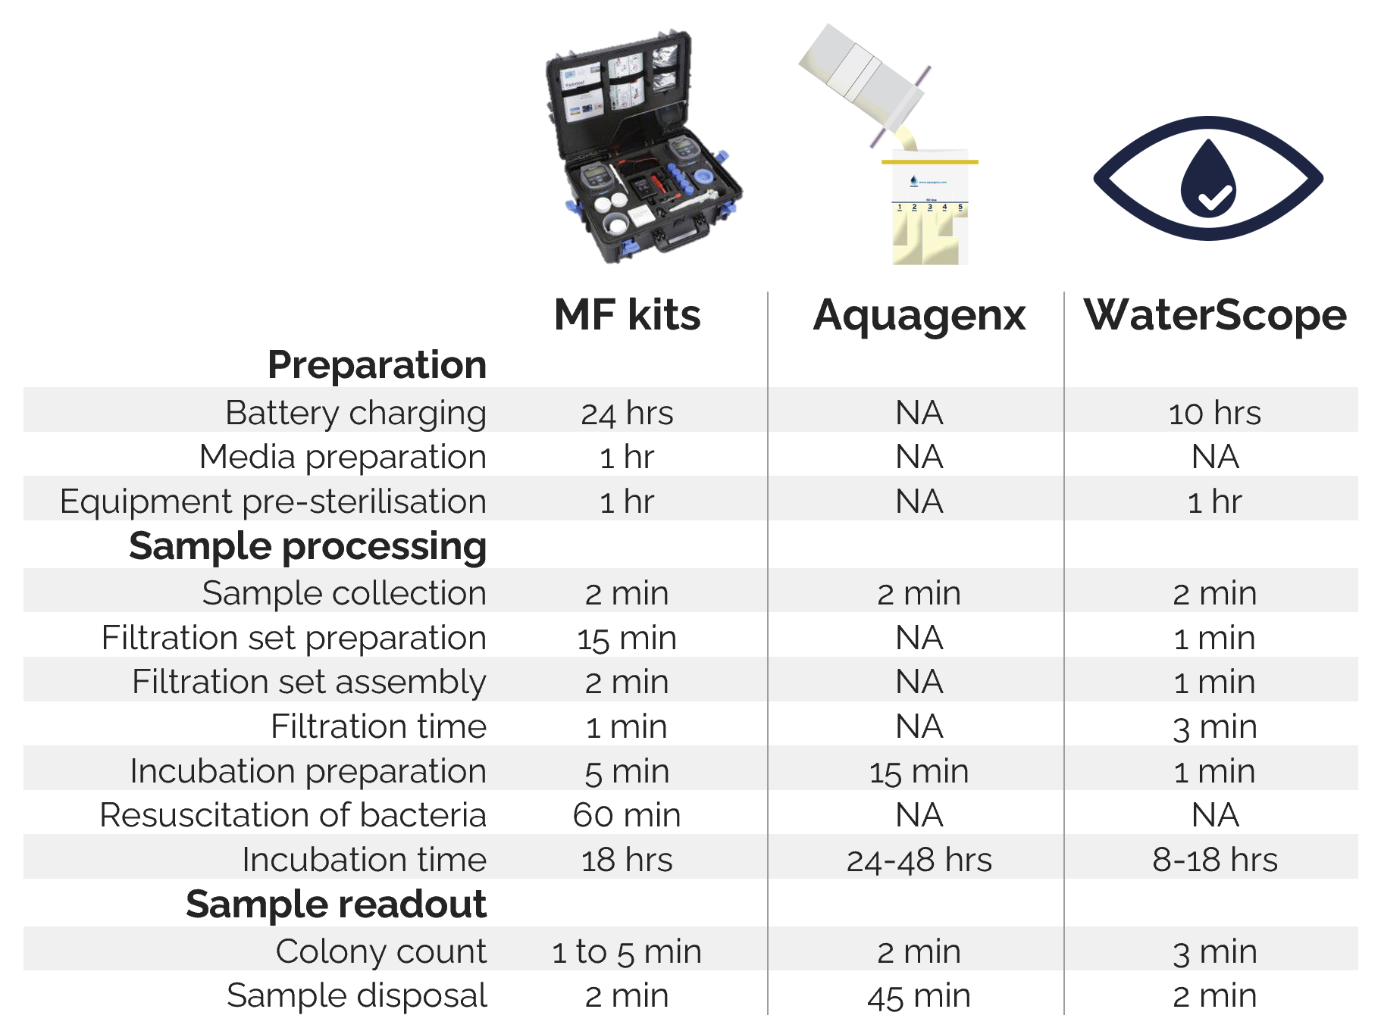
Figure 1. Comparison of portable water test kits in terms of sample processing time.

The WaterScope system allows for tests to be conducted much quicker in the field (8 minutes in total), which means that the user can increase their daily throughput and screen multiple water sources throughout the day. The WaterScope system also offers more additional features in comparison to the other two alternatives. These are summarised in Figure 2 below. One disadvantage of the WaterScope system in comparison to the MF systems is the higher price (system and consumable). However, over the life of the system (1000 tests over 3 years), the overall cost per test including labour costs is only slightly higher (Figure 3 below). The added benefits are easier sample preparation (lower false positives, higher throughput, less training), the ability to detect E.coli directly, same day risk level assessment and digital features (automated counting, Android App and online dashboard with mapped results).

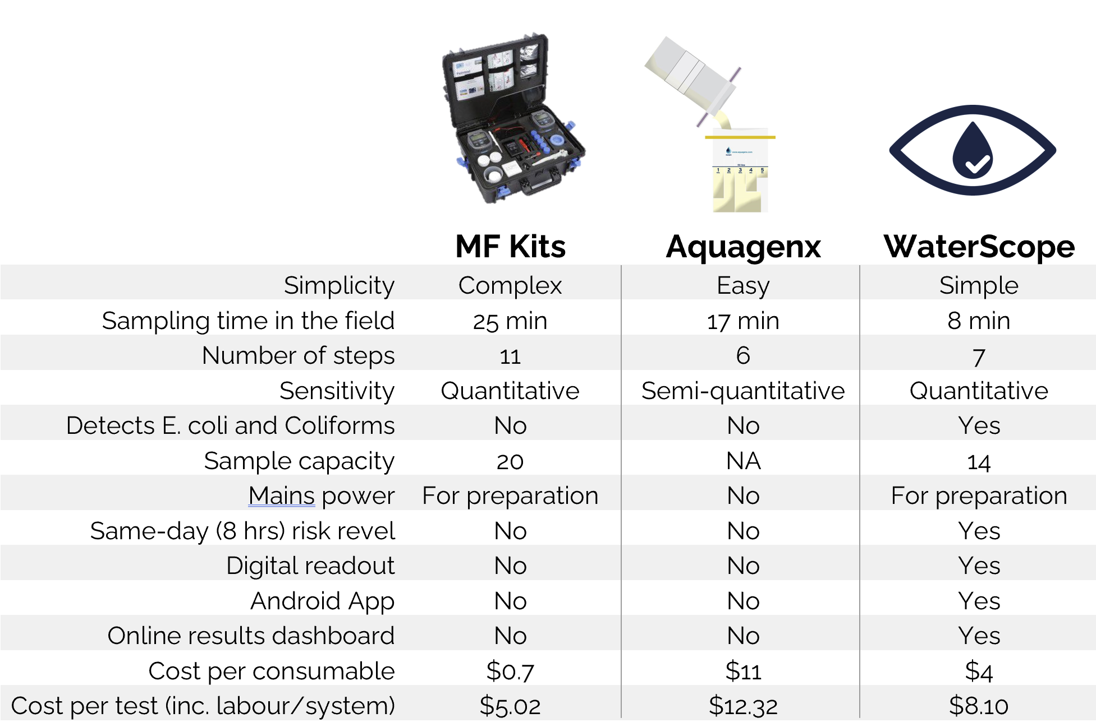
Figure 2. Comparison of water test kits in terms of features and cost per test.
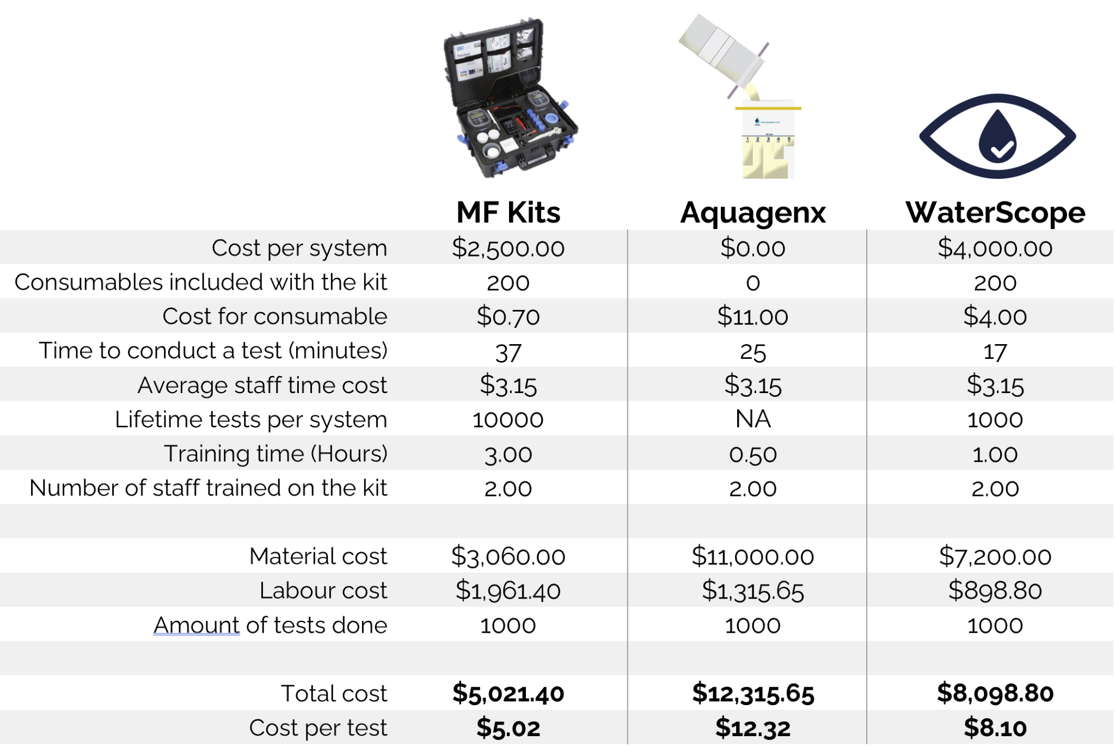​​Figure 3. Cost comparison of water testing kits.

